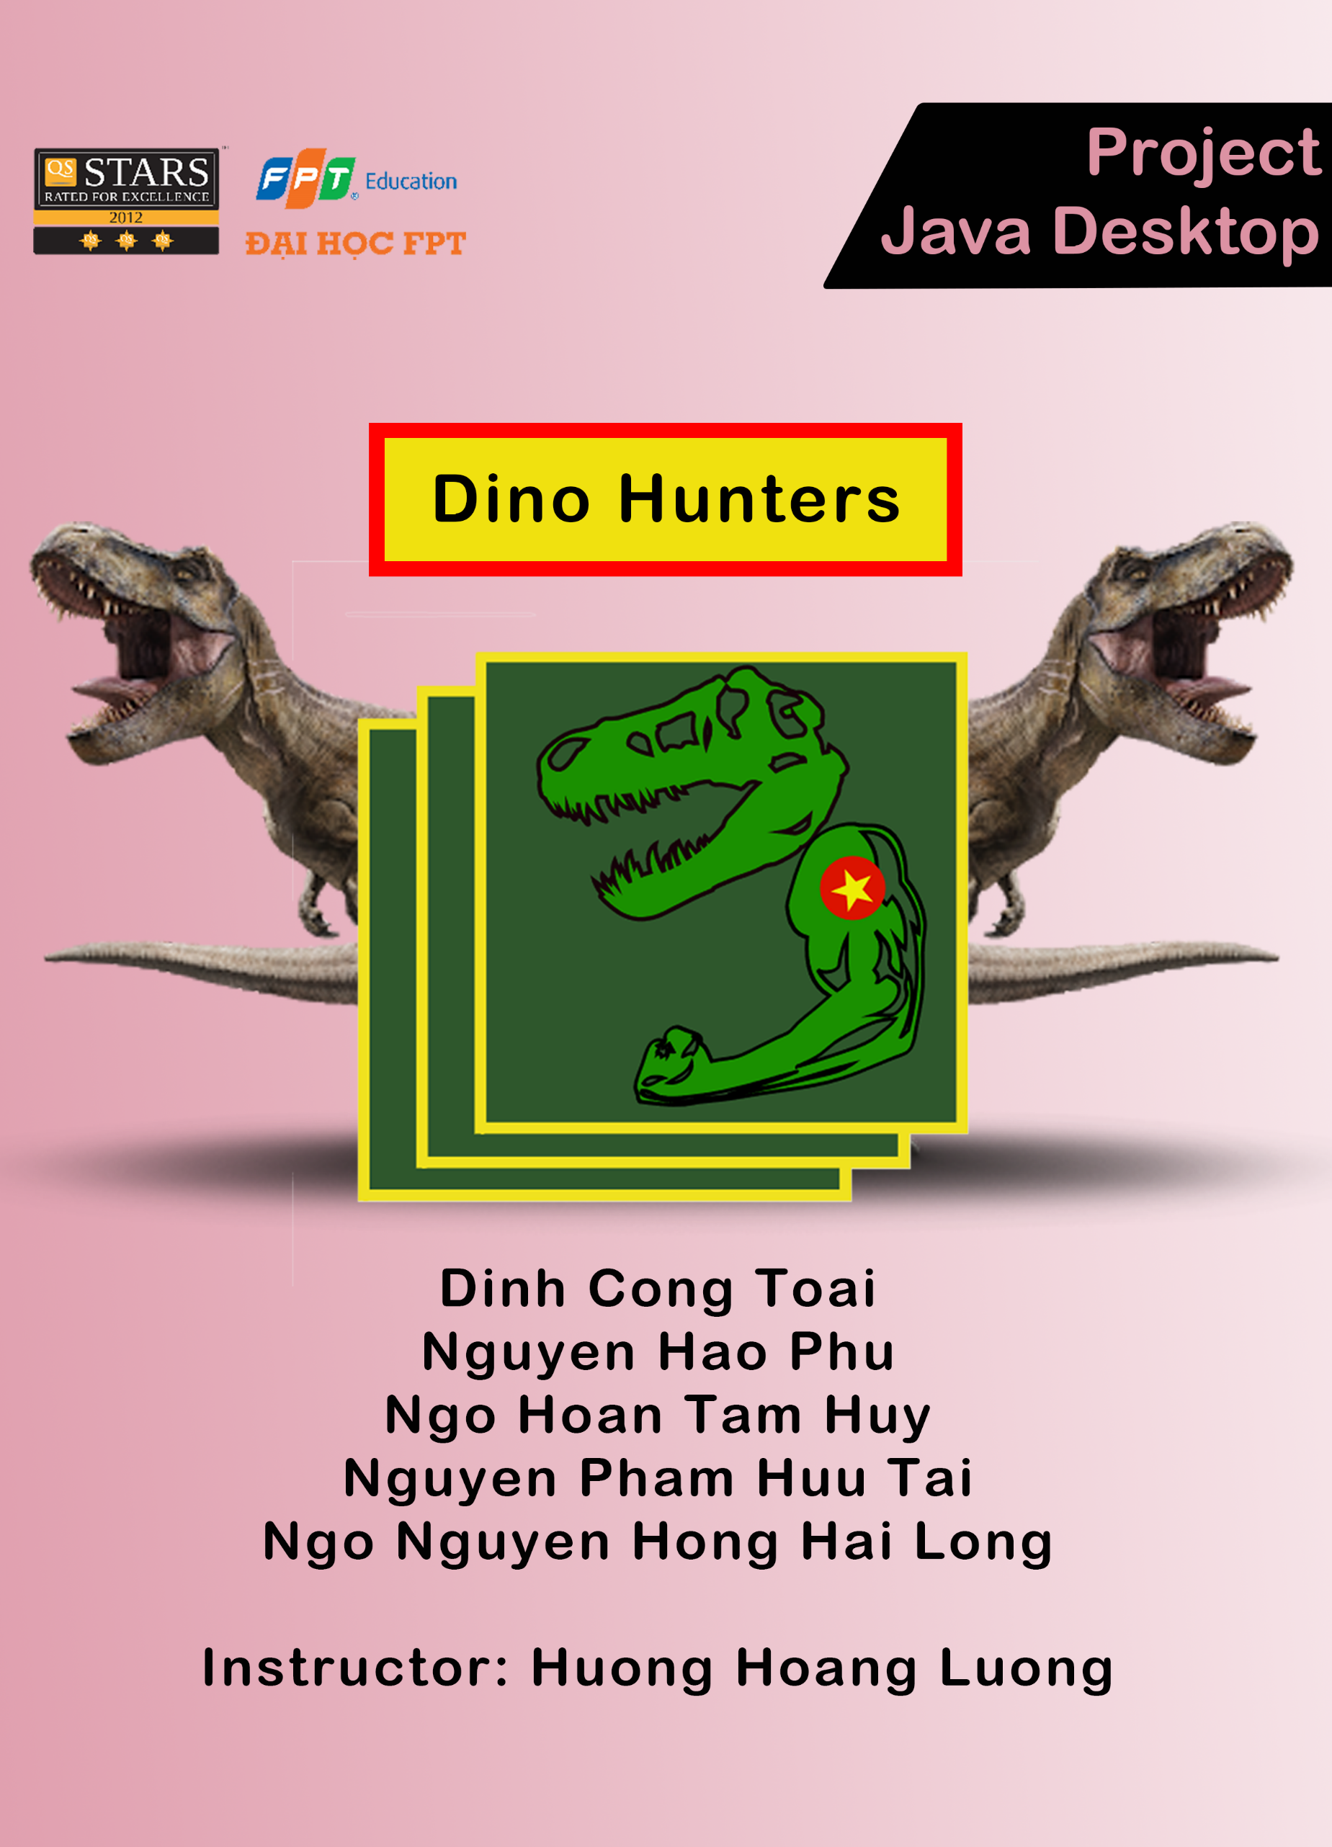

**Table of content**

**Greeting....................................................................................2**

1. **Abstract.............. .....................................................................3**
2. **Problem definition and goal ......................................................4**
3. **Problem detail...........................................................................5**
4. **Object and scope of the study....................................................6**
5. **Schedule ..................................................................................7**
6. Hardware and Software requirements**.......................................8**
7. User requirements......**...............................................................9**
8. **Class Diagram ..........................................................................10**
9. **User interface ..........................................................................12**
10. **Data Analysis...........................................................................19**
11. **Checklist .................................................................................20**
12. **Project Detail............................................................................21**

GREETING

GREETING

According to the assignment of Master Lương Hoàng Hướng, we decided to make an application to manage hotel information. To complete this project, we are so thankful to Mr. Hướng to teach us much knowledge about Object-Oriented Programming using Java and Desktop Java Applications. We couldn’t finish this without you.

This product maybe our best effort at this moment. However, there are a lot of things we need to discuss more, learn more and fix more after this subject to improve our skills in the future. We love to get many suggestions about this project from teachers and classmates to improve our next projects.

Many thanks to everybody!

Can Tho City, March 25, 2020

Partipation

Đinh Công Toại

Nguyễn Hào Phú  
Ngô Hoàn Tâm Huy

Nguyễn Phạm Hữu Tài

Ngô Nguyễn Hồng Hải Long

1. ABSTRACT

Many millions of years ago, reptiles, especially dinosaurs, themselves rule our planet instead of humanity. From tiny creatures to very large creatures, from carnivores to herbivore. By the time, with the change of the Earth, the evolution of many species and the Natural Selection, dinosaurs have been extinct and now we just can know them through pictures, arts and movies.

Besides, fossils and skeletons of dinosaurs are just being shown in a few countries on the world and dinosaurs’ informations can not come to many people in the modern world. To help people in the modern world know more about those extinct creatures, we are going to sell dinosaurs figures.

Thanks to modern technology, each figure will come along with informations about that dinosaur. A program named “**Dinosaur Figures Shop**” is built to bring informations of dinosaurs to every customers of our company whenever they buy dinosaur figures.

1. Problem definition and goal

Problem:

Nowadays the online business model is becoming popular due to the development of the Internet, customers can order the items they want at any time and where. Dinosaurs is the most popular theme and many people want to study or have figures of them. Therefore Manage Dinosaurs’ Data program is nessesary.

The program should be customer-friendly, have tools such as search, sort, rating and sales report. Also have manager access to manage customers and items info.

Goal:

The goal of this project is create a Java program to manage dinosaurs data that also a dinos figure store. Customer can use this program to search and buy figures easily. The data will be store in SQL database.

The product of this project is a program Dinosaur Figures Shop. This is a Java program using SQL database.

1. PROBLEM DETAIL

This is a small project about an oline shop selling Dinosaur figure .In this shop we have the lated dino figure from everywhere around za warudo, it will be update by admin everyday and can be restock. Client can buy, rating their favorite figure. The shop also have sorting function by figure name, rating and so on.

Now we go into detail of our design for this system:

At the beginning, the system would ask client to enter their username and password to clarify to data in sql server and base on whether they are admin or an client the program will pop up two diffent kind of wndow.

|  |  |
| --- | --- |
| User Window:  +Buy  +Rating  +Sort  +Change Password  +Add money | Admin:  +Add DinoFig  +Delete DinoFig  +Update DinoFig info  +User Management  +Buy History |

1. OBJECT AND SCOPE OF THE STUDY

Target users of this document are students and others who are passionate about or need to research the programming of sales management software on the Desktop in Java language on NetBeans IDE 8.2, the basic management system SQL Server.

The scope of the study is the theoretical basis of Java language desktop application programming on NetBeans IDE 8.2. MySQL database management system.

1. SCHEDULE

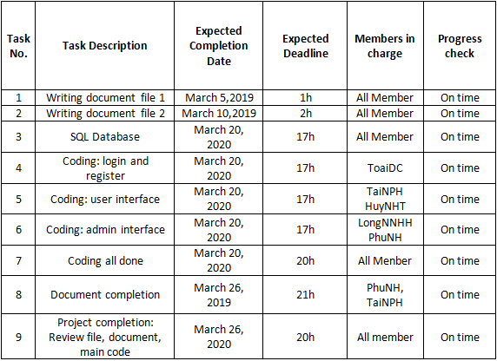

1. Hardware and Software requirements
2. **Hardware requirements:**

|  |  |  |
| --- | --- | --- |
|  | **Minimal configurations** | **Recommended configurations** |
| **CPU** | **500 MHz Intel Pentium III workstation or equivalent** | **780 MHz Intel Pentium III workstation or equivalent** |
| **RAM** | **384 megabytes** | **512 megabytes** |
| **HDD** | **125 megabytes of free disk space** | |

1. **Software requirement**s:

- Windows 7 or higher

- NetBean 8.

- SQL Server Management Studio 8 or higher

1. USER REQUIREMENTS
2. **Login interface**

There is one account for admins, users and admin can login from here

If users don’t have account, they can regist account

1. **User interface**

There is a reccomend list for users in the main page and for buttons, which are “Shop”, “Main page”, “Purchase History” and “About Us”.

+ Main page button will allow users to comeback to the main page

+ Shop button will allow users to go to Shop page

+ Purchase History button will allow users to see their purchase history in our shop

+ About Us will allow users to see our’s informations

Moreover, there are two others button:

+ Optional button will alow users to choose 2 more options:

+ To change their password

+ To change their informations

+ Exit button will let user comeback to the Login interface

1. **Admin interface**

We can see informations of admin in here.

There are three things that admin can do:

+Manage users’ informations

+Manage items

+Check login history of user

And a Logout button will allow admin to comeback to the login page

1. CLASSES DIAGRAM
2. 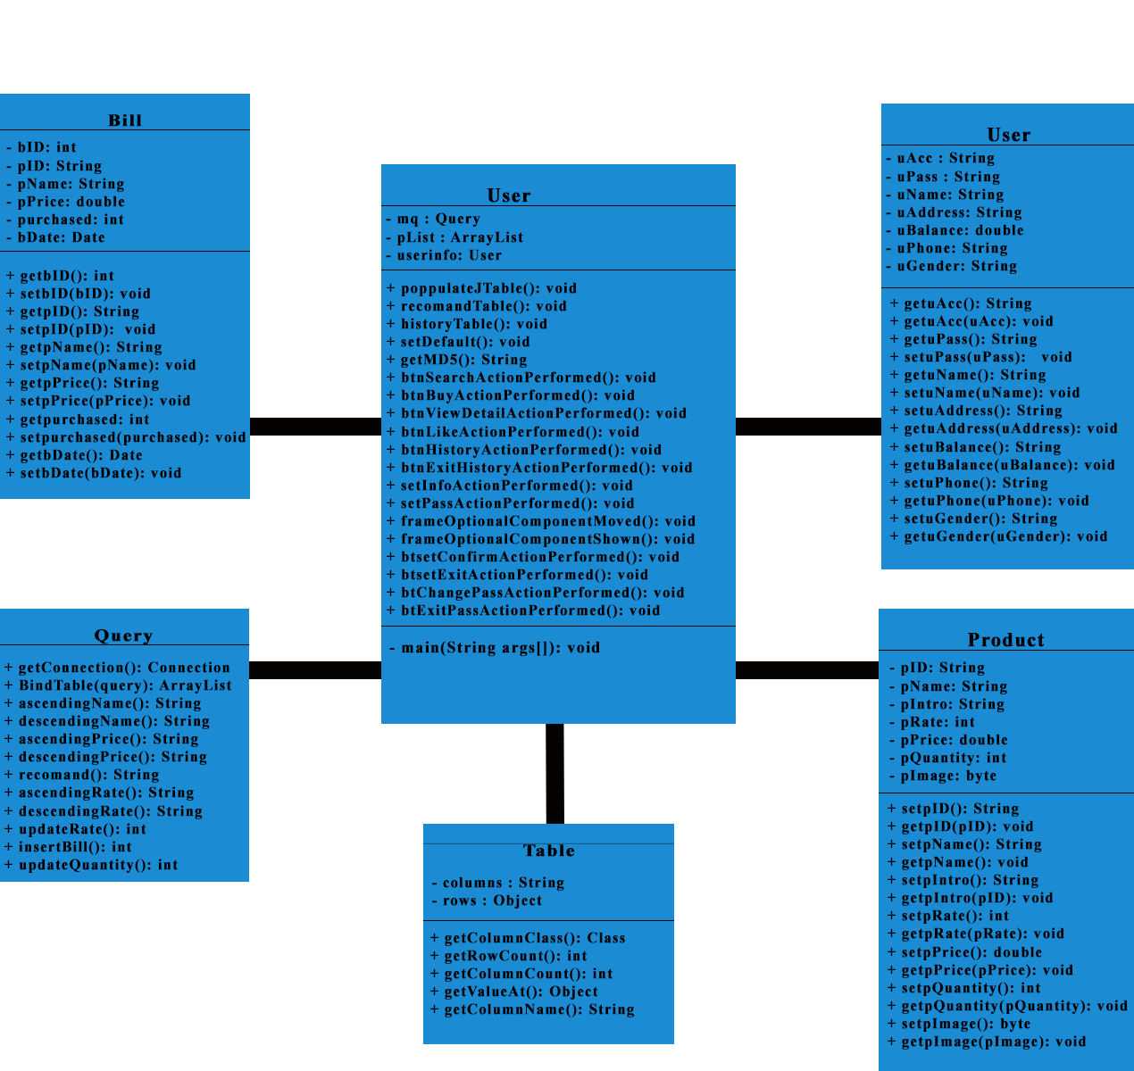User’s interface
3. 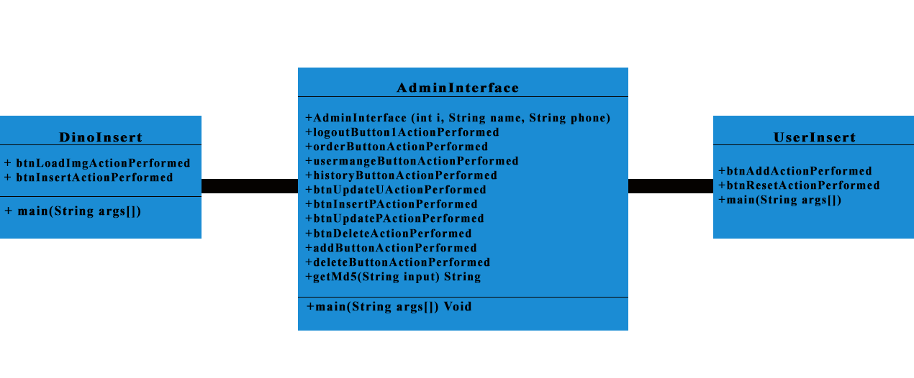Admin’s interface

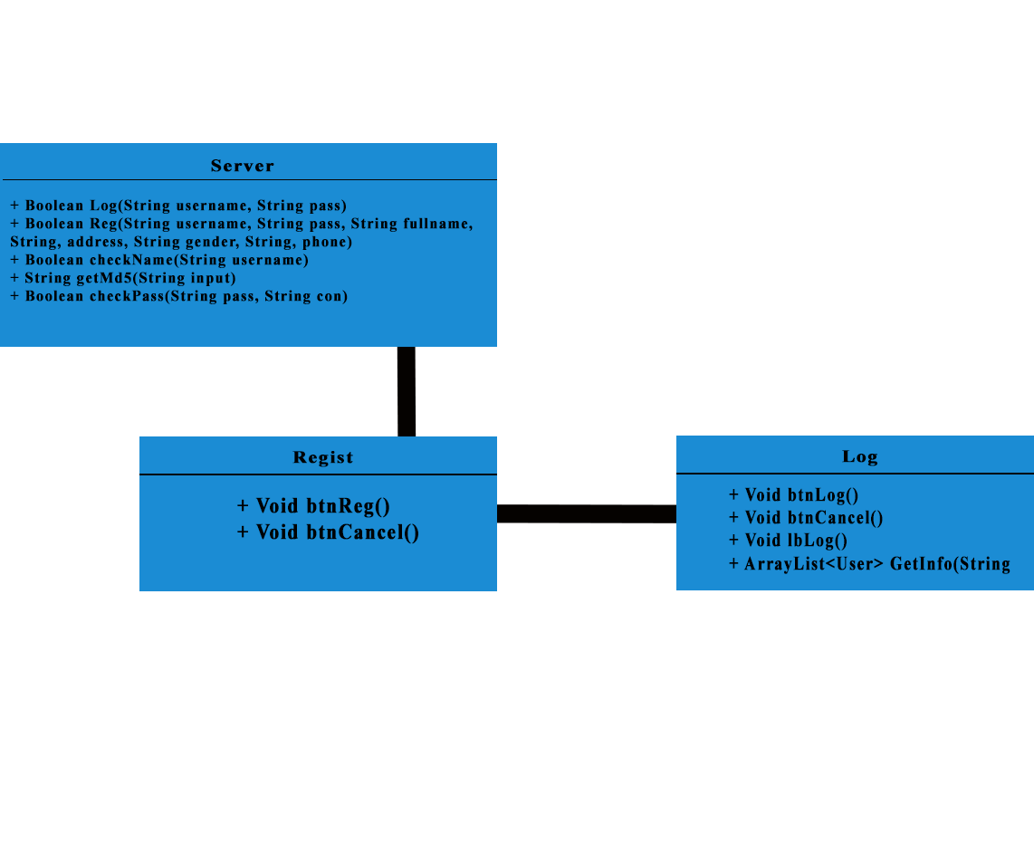

1. Login interface

1. PROJECT’S INTERFACES

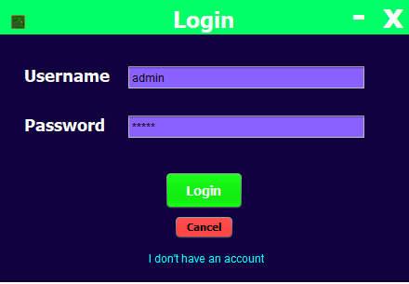

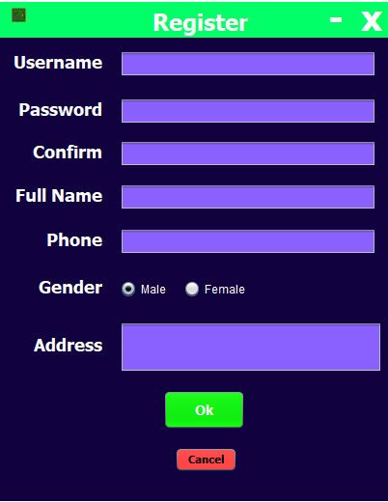

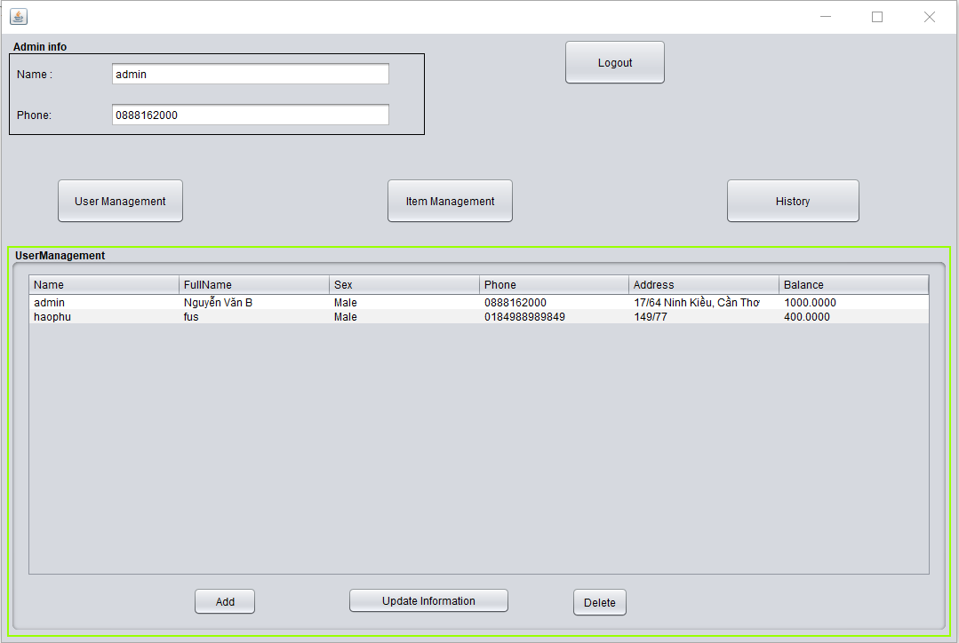

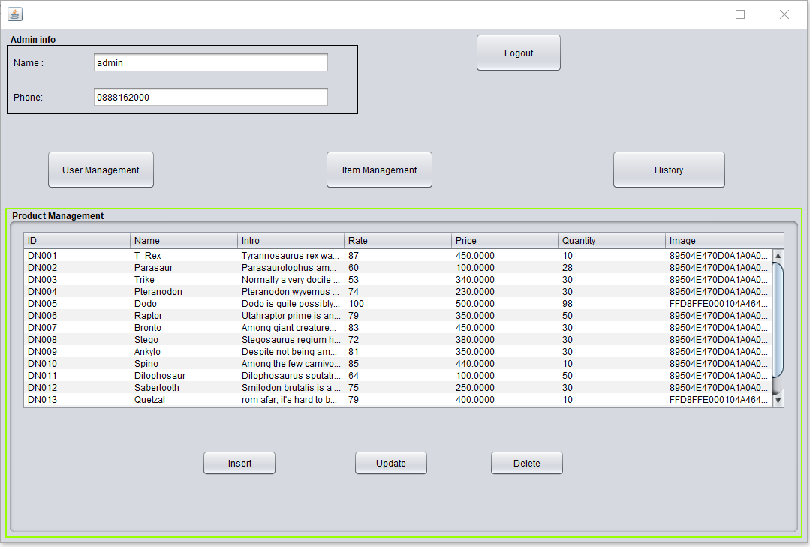

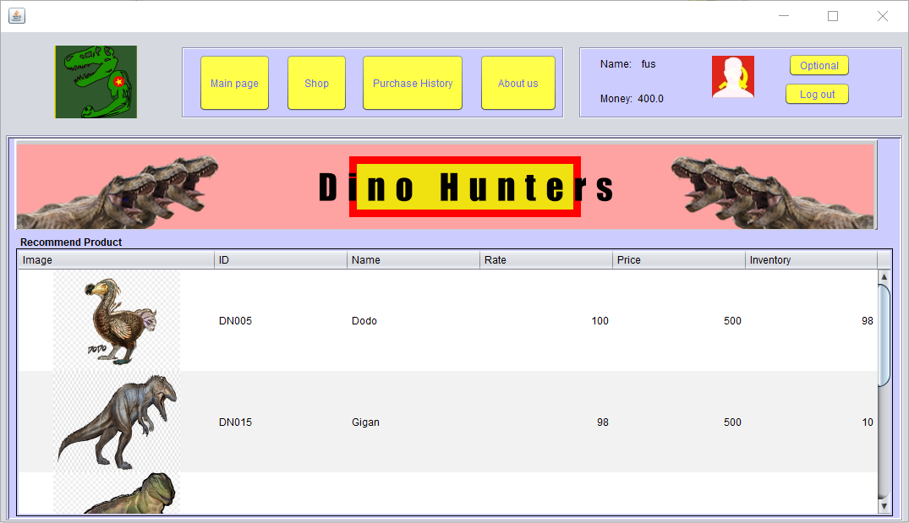

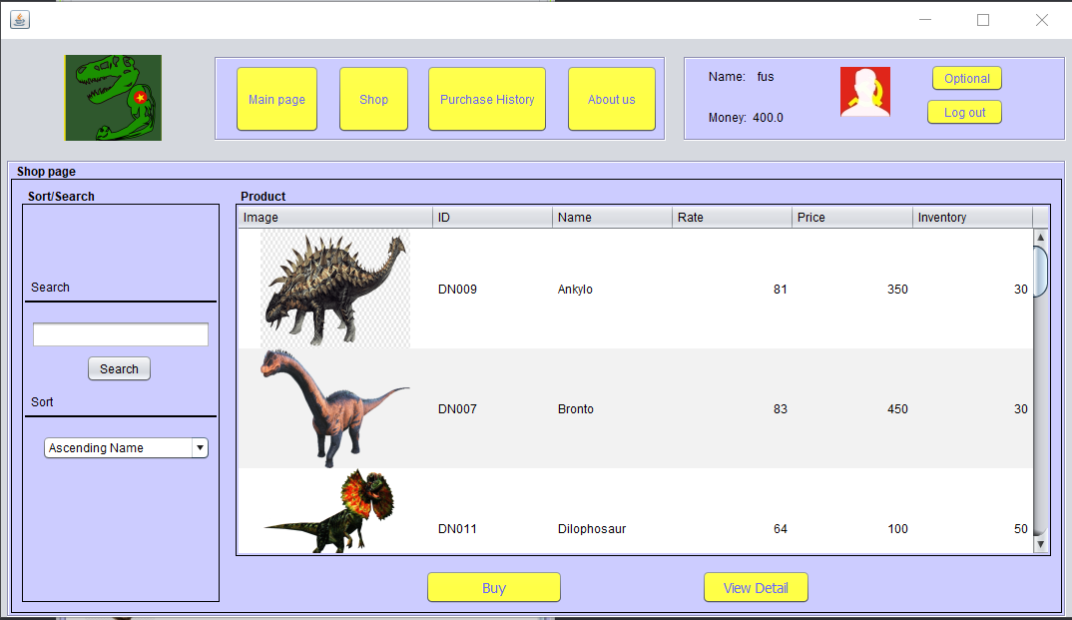

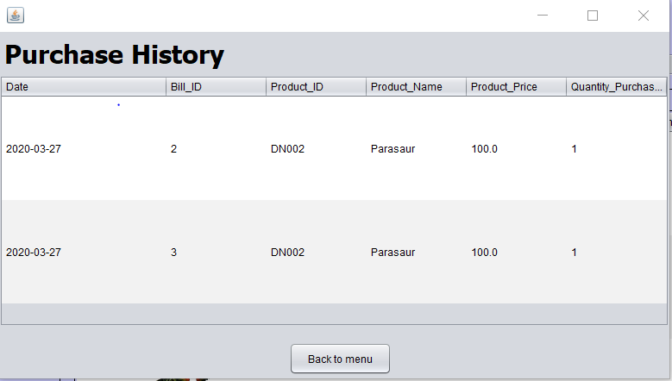

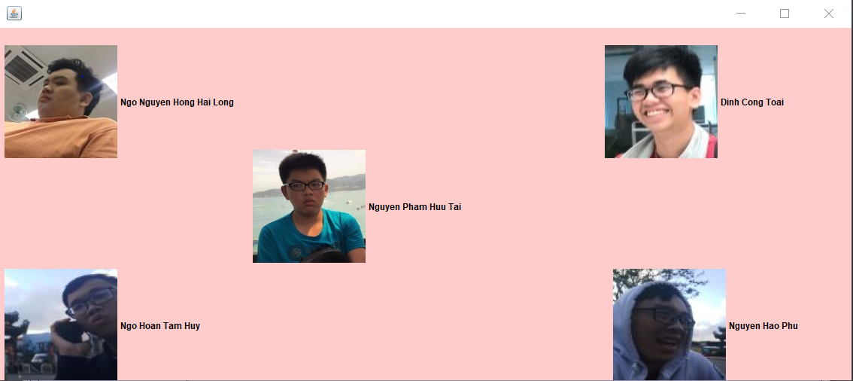

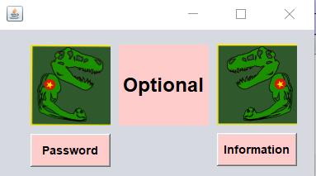

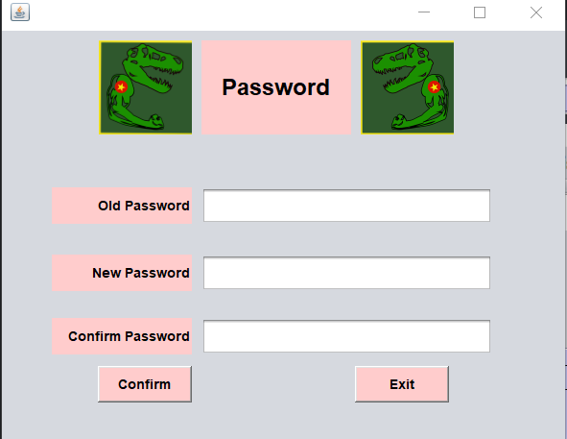

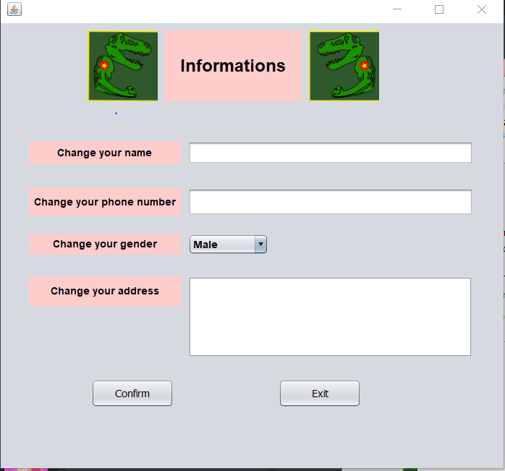

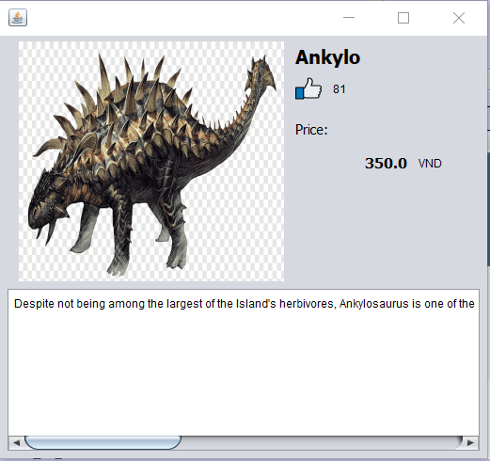

1. DATA ANALYSIS

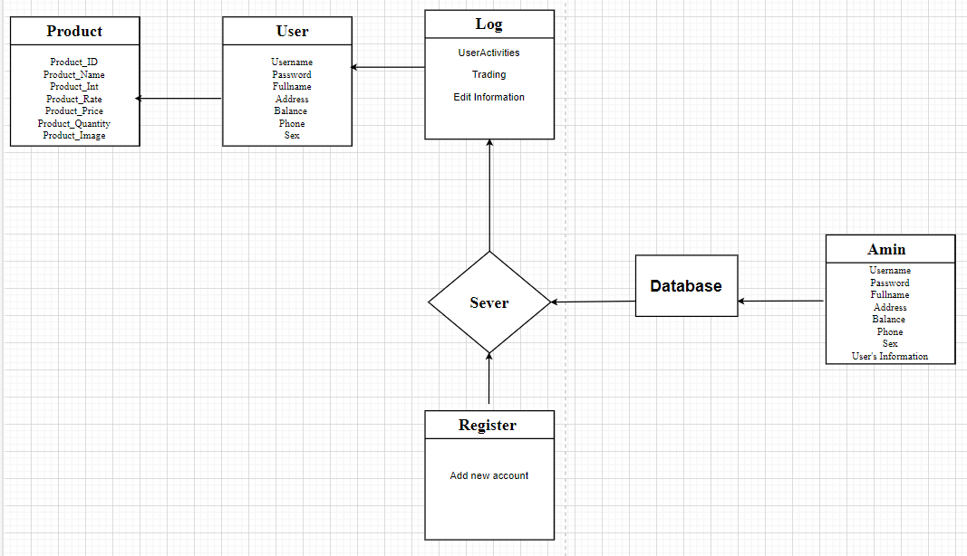

1. CHECK LIST



1. PROJECT DETAIL
2. **About the client**:

- Name of Client: Luong Hoang Huong

- Address: FPT University, Nguyen Van Cu Street, An Binh Ward, Ninh Kieu District, Can Tho.

- E-mail address: huonglh3@gmail.com

**2. About the group:**

- Name of group: Dino Hunters

+ Leader: Nguyen Hao Phu

+Coder: Ngo Nguyen Hong Hai Long, Dinh Cong Toai, Nguyen Pham Huu Tai, Ngo Hoan Tam Huy, Nguyen Hao Phu

+Designer: Nguyen Pham Huu Tai, Dinh Cong Toai

- Address: FPT University, Nguyen Van Cu Street, An Binh Ward, Ninh Kieu District, Can Tho

- Email address: phunhce140069@fpt.edu.vn (Phu)